Transitpay
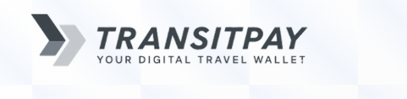

Gitforce

Sunway College | Codaarambha

Contents
Executive Summary 3
Problem Statement 5
Gaps in existing solutions 6
Proposed Solution 7
User Pipeline 8
Features 9
Unique selling points 11
Business model 13
Accessibility Source 14
Cost breakdown 15
Timeline 16
Acknowledgement 17

Executive Summary
Public transportation in Nepal, particularly in Kathmandu Valley and other major cities, serves as the backbone of daily mobility for millions of people. Despite its importance, the fare collection system remains largely manual, cash-based, and vulnerable to exploitation, resulting in persistent challenges such as overcharging by conductors, lack of transparency, revenue leakage, and passenger inconvenience. Passengers often face inconsistent fares, insufficient change, and disputes, while operators struggle with unaccounted revenue and inefficiencies. Existing digital solutions are limited, poorly implemented, or fail to address inclusivity and transparency, leaving a significant gap in Nepal’s public transport ecosystem.
To overcome these challenges, we propose TransitPAY, a technology-driven fare management ecosystem that integrates NFC-based tap-in/tap-out functionality, distance-based fare deduction, digital wallet integration, and a reward and loyalty system. TransitPAY ensures passengers are charged accurately based on distance traveled, eliminates cash handling, prevents fraud, and enhances trust in public transport operations. By leveraging real-time journey tracking, encrypted transactions, and secure ID-linked discounts for students, senior citizens, and differently-abled users, the system prioritizes inclusivity, transparency, and efficiency.
Key features of TransitPAY include automated fare deduction, NFC-enabled payments for both smartphone and non-smartphone users, reward points for frequent travelers, and real-time analytics for operators and city planners. The system aligns with Nepal’s Digital Nepal Framework and the Nepal Rastra Bank’s cashless initiatives, promoting digital payment adoption while enabling data-driven improvements in urban mobility.
The proposed business model is sustainable and scalable, generating revenue through a nominal 2 NPR transaction fee, which could yield 10 million NPR per day at full-scale adoption with 5 million daily users. This model ensures value for passengers, operators, and government agencies by reducing fraud, enabling transparent fare management, and providing actionable data insights.
TransitPAY is designed with accessibility and inclusivity at its core. Physical NFC cards ensure participation for digitally excluded populations, while ID-linked discounts and simplified onboarding promote fair pricing and ease of use. This focus on inclusivity addresses challenges highlighted by studies such as the World Bank Report on Gender and Public Transport in Nepal, which emphasizes the need for accessible transport solutions for women, elderly, and differently-abled individuals.
A detailed timeline and roadmap outlines phased implementation, from hackathon prototype development to pilot testing in Kathmandu, refinement and scaling, and eventual public launch.
The long-term vision positions TransitPAY as a nationwide solution capable of supporting millions of commuters, fostering a cashless, transparent, and efficient public transport ecosystem in Nepal.
In summary, TransitPAY represents a holistic, inclusive, and scalable solution that addresses existing gaps in Nepal’s public transportation, empowers passengers, strengthens operator efficiency, and supports the government’s vision for digital transformation in urban mobility.

Authors:
Success Bishwakarma
Hritik Shrestha

Problem Statement
Public transportation in Nepal, particularly in Kathmandu Valley and other major cities, remains the backbone of daily mobility for millions of people. However, the fare collection system is still predominantly manual, cash-based, and highly vulnerable to exploitation. This has created a series of persistent problems for both passengers and transport operators:
- Overcharging and Fraud by Conductors:
Conductors often take advantage of passengers—especially newcomers, students, and tourists—by charging more than the official fare. Reports show that even a small manipulation, like adding Rs 2 per passenger, can generate significant illicit income when multiplied across thousands of daily commuters (Kathmandu Post). This erodes passenger trust and creates unfairness in the system.
- Lack of Change & Cash Dependency:
Passengers frequently face inconvenience when conductors cannot return exact change. This forces commuters to overpay or engage in disputes. Since fares are mostly cash-only, commuters must carry lose money every day, which is impractical in an age of growing digital wallets like IME Pay and Namaste Pay (Nepali Times).
- Lack of Transparency in Fare Structure:
Bus fares in Nepal fluctuate due to fuel price hikes and are often poorly communicated to the public. This confusion allows conductors to exploit passengers, as many are unaware of the exact, updated fare for their route.(Kathmandu post).
- Revenue Leakage for Operators:
Because fares are collected manually, operators have little control over how much money is actually collected and reported by conductors. A significant portion of revenue is “leaked” through fraud, directly impacting transport companies’ sustainability. (Annapurna express)

Gaps in existing solutions
In the past, several attempts were made to introduce NFC chip-enabled payment systems in Nepal’s public transportation sector. However, these initiatives faced multiple challenges that prevented large-scale adoption and sustainability.
1. Interoperability Gap: Earlier systems were fragmented and worked only within specific transport operators. Passengers could not use a single NFC-based solution across all buses, creating inconvenience and limiting adoption. Proposed Resolution: Our system ensures universal interoperability by equipping every bus in Kathmandu with NFC-enabled payment features, allowing commuters to use one solution citywide.
2. Recharge Friction Gap: Passengers had to recharge cards manually through limited kiosks or agents. Lack of integration with popular payment channels made the process slow and inconvenient. Proposed Resolution: The emergence of digital wallets (e.g., eSewa, Khalti, IME Pay) has reduced recharge friction. Users can now top-up instantly through mobile wallets, ensuring a smoother payment experience.
3. Technical Issues Gap: Ticketing devices previously suffered from short battery life, leading to failures during long bus operations. Hardware breakdowns forced operators to revert to cash collection, undermining trust. Proposed Resolution: Our system incorporates modern NFC devices with improved battery performance and backup mechanisms, ensuring reliability throughout daily operations.
4. Insufficient Network Integration Gap: Previous systems lacked proper integration among different transport operators. This resulted in fragmented data, inefficiencies in fare collection, and difficulties in managing subsidies. Proposed Resolution: Our solution establishes a centralized integration platform connecting all operators, wallets, and stakeholders. This enables real-time data sharing, transparency, and efficient revenue management.

Proposed Solution
To address the problems of overcharging, lack of transparency, and revenue leakage in Nepal’s public transportation system, we propose a technology-driven fare management ecosystem built on the following pillars:
1. Tap-In Tap-Out System
Passengers will “tap” their NFC-enabled card or smartphone at entry (tap-in) and exit (tap-out) points of the bus. The system automatically logs journey details in real-time, ensuring precise boarding and alighting records. This eliminates manual fare collection, prevents fraud, and guarantees fairness in fare calculation.
- Example: Sajha Yatayat previously piloted a tap-to-pay smart card in Nepal (prnewswire.com).

2. Distance-Based Fare Deduction
Instead of flat rates, fares are deducted proportionally to the distance traveled. For example, a passenger traveling a short distance pays less than one traveling across the city. This is not only fairer but also discourages conductors from arbitrary fare demands.
- Kathmandu’s official fare structure is already distance-based (as per Bagmati Province Gazette) but poorly enforced in practice (kathmandupost.com). Automating it ensures compliance.

3. Reward System (Loyalty & Incentives)
To encourage adoption, frequent travelers will earn loyalty points or cashback in their linked digital wallets (e.g., IME Pay, Namaste Pay). For instance, after every 20 rides or in 100km users may receive a small cashback or free ride. This boosts user trust, strengthens adoption, and integrates seamlessly with Nepal’s growing digital payment ecosystem (nepalitimes.com).

User Pipeline

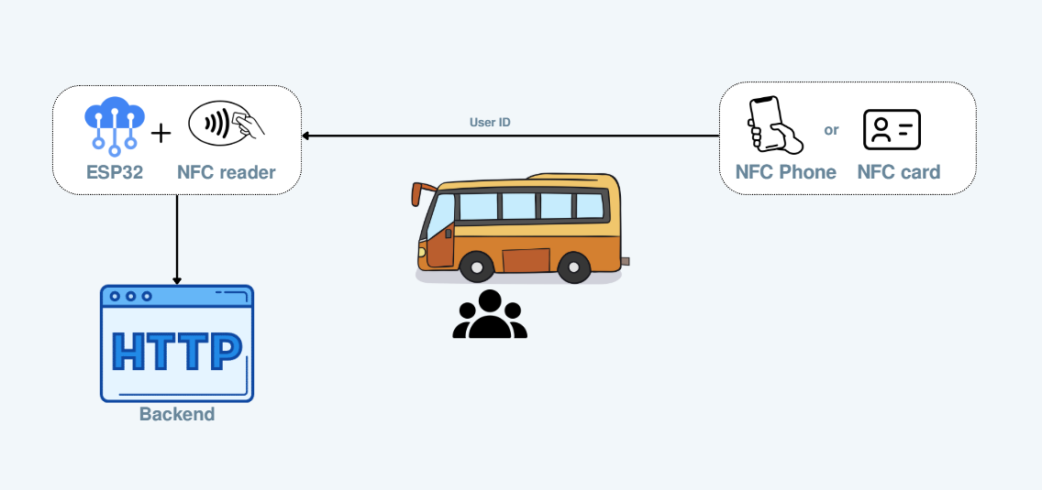

Features

- Tap-In Tap-Out Functionality
- How it works: Passengers tap their NFC-enabled card or smartphone when boarding and exiting the bus.
- Benefits:
  - Eliminates manual fare collection and disputes.
  - Records accurate entry and exit points for each passenger.
  - Prevents overcharging by conductors.
- Local context example: Piloted by Sajha Yatayat (PR Newswire).
2). Distance-Based Fare Deduction
- How it works: Fare is automatically calculated based on the distance traveled.
- Benefits:
  - Ensures fair pricing for short and long trips.
  - Removes fare ambiguity and reduces passenger complaints.
- Local context example: Aligns with Kathmandu fare regulations (Kathmandu Post).
3). Digital Wallet Integration
- How it works: Fares are deducted directly from digital wallets like IME Pay or Namaste Pay.
- Benefits:
  - Cashless transactions for convenience.
  - Reduces dependency on small change.
  - Enables automatic recording of all transactions.
- Local context example: Nepal’s growing digital payment ecosystem (Nepali Times).

4). Reward & Loyalty System
- How it works: Users earn points or cashback for frequent travel.
- Benefits:
  - Encourages repeated use of public transport.
  - Increases user adoption of digital fare system.
  - Can be tied to discounts on future rides.
5). Real-Time Journey Tracking & History
- How it works: The app shows users detailed trip history, fare deductions, and travel logs.
- Benefits:
  - Passengers can verify charges instantly.
  - Increases transparency and trust.
  - Helps operators analyze ridership patterns.
6). Fraud Prevention & Security
- How it works: NFC-based authentication ensures only valid cards or registered devices are used.
- Benefits:
  - Prevents fake tickets or duplicate card use.
  - Minimizes revenue leakage for operators.
  - Secures passenger data with encrypted transactions.

Unique selling points

1. Cashless and Transparent
TransitPAY eliminates the chaos of cash handling and fare manipulation by enabling digital, automated transactions. Every payment is traceable, ensuring trust, accountability, and transparency across passengers, drivers, and operators.
2. Convenience and Efficiency
With NFC-enabled phones and physical cards, boarding becomes significantly faster. Payments are seamless, reducing wait times and improving overall efficiency for both commuters and transport operators.
3. Inclusivity for All
The system provides virtual cards for smartphone users and physical NFC cards for students, senior citizens, differently abled individuals, and those without smartphones. Discounted fares are automatically applied via ID linking, making public transport fair and inclusive.
4. Reward-Driven Adoption
Unlike conventional digital fare systems, TransitPAY incorporates a reward mechanism. Regular commuters earn points for their usage, which can be redeemed as travel balance or withdrawn, directly incentivizing public transport usage.

5. Data-Driven Optimization
TransitPAY collects anonymized passenger flow data in real time. This empowers operators and city planners with insights for route optimization, demand prediction, and traffic decongestion, ultimately enhancing urban mobility.

Business model

Our proposed TransitPAY system operates on a transaction-based revenue model, ensuring sustainability while providing value to passengers, transport operators, and the government.
Revenue Sources
- Transaction Commission (Platform Fee):
  - A nominal fee of 2 NPR per transaction is applied on every ride processed through the platform.
- Scalability Example: With 5 million daily users, this generates approximately 10,000,000 NPR per day, demonstrating significant revenue potential while keeping fares affordable.

benefits Value Proposition
- For Government:
  - Promotes fare transparency and enables data-driven oversight of public transport operations.
  - Reduces opportunities for fraud and revenue leakage in cash-based fare systems.
- For Transport Operators:
  - Simplifies fare collection and accounting.
  - Provides real-time passenger flow data for operational planning.
- For Passengers:
  - Ensures fair and accurate fares.
  - Enables cashless convenience and loyalty/reward.
By combining a small transaction fee with digital monitoring and rewards, the system balances revenue generation with social impact, supporting Nepal’s move toward cashless, transparent, and efficient public transport.

Accessibility Source
The TransitPAY system is designed to ensure equal access for all passengers, regardless of their digital or physical limitations.
- For smartphone users: NFC-enabled virtual cards allow seamless tap-in/tap-out using mobile devices.
- For non-smartphone users: Physical NFC cards are provided, ensuring inclusion of digitally excluded populations such as senior citizens, students, and differently-abled individuals.
- ID-linked discounts: Automatically applied for eligible groups, eliminating the need for manual verification and ensuring fair pricing.
- Barrier-free adoption: Simplified onboarding ensures that those unfamiliar with digital payments can easily recharge their cards at kiosks, bus counters, or mobile wallets.

- A study by the World Bank highlights that public transport in Nepal is often inaccessible to women, elderly, and differently-abled individuals, stressing the need for inclusive solutions (World Bank Report – Gender and Public Transport in Nepal).

Cost breakdown

Timeline

Phase 1 – Research & Planning (Week 1)
- Study existing transport systems in Nepal (Sajha Yatayat, Yatayat apps).
- Gather government fare rules and integrate into system logic.
- Finalize technology stack (NFC integration, mobile app, backend wallet).
Phase 2 – Prototype Development (Weeks 2–3)
- Build mobile app with tap-in/tap-out system and digital wallet integration.
- Develop NFC card reader/writer module for passengers without smartphones.
- Create basic admin dashboard for operators (route data, fare collection).
Phase 3 – Pilot Testing (Week 4)
- Test with selected buses in Kathmandu.
- Collect feedback from passengers, conductors, and operators.
- Debug and improve fare deduction accuracy (distance-based).
Phase 4 – Refinement & Scaling (Weeks 5–6)
- Add reward system and ID-linked discounts (students, seniors, differently-abled).
- Implement fraud prevention & security features.
- Expand pilot to multiple routes.
Phase 5 – Public Launch (Month 2 onwards)
- Deploy to major bus operators in Kathmandu Valley.
- Run awareness campaigns with passengers and drivers.
- Scale toward 5M daily user adoption goal under Digital Nepal vision.

Acknowledgement
This project would not have been possible without the support and dedication of our incredible team. We extend our gratitude to mentors, institutions, and volunteers who guided us throughout the process.
Special thanks to:
- [Prashant Adhikari]
- [Rojin Baniya]
Your efforts, insights, and teamwork played a vital role in bringing this project to life.

